Data structure lab

roshni raza

61278

[Year]

**Task no.01**

#include<iostream>

using namespace std;

int main(){

int arr[5]={2,4,5,5,5};

int *ptr=arr;

for(int i=0;i<5;i++){

cout<<*ptr<<endl;

ptr++;

}

return 0;

}

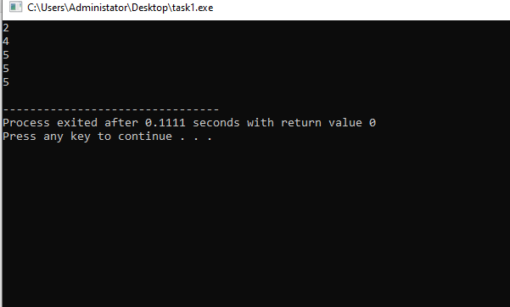

**Task no.02**

#include<iostream>

using namespace std;

void swap (int* a, int* b){

int c=*a;

*a = *b;

*b=c;

}

int main(){

int n1=5;

int n2=7;

cout<<"before swap"<<n1<<" "<<n2<<endl;

swap(&n1,&n2);

cout<<"after swap"<<n1<<" "<<n2;

return 0;

}

